|  |  |  |
| --- | --- | --- |
| cid:73148A18-5859-42A3-B556-365FB92F1518@ncc.lan |  | Pastor Chris Brown  May 9-10, 2020  Message #15/Acts 6:8-15 |
|  | northcoastchurch.com/sermons |

**Why The Church Will Never Be Closed**

**Today’s golden thread = serving:**

Acts 1-6

Food drive recap:

When do the buildings open again?

How was April?

Acts 6 & 7:

Exodus 2:1-10:

Jesus’ last example & commands:

Our response?

**Just in case you missed the point:**

* Serving is not an **OPTION** in the **CHRISTIAN** life; it **IS** the **CHRISTIAN** life.
* We are never **CLOSER** to the Holy Spirit than when we are **SERVING**, and we are

never **FURTHER** from the Holy Spirit than when we are expecting to be **SERVED**.



**Life Group Study Questions**

For the week of May 10, 2020

**Quick review**

Looking back at your notes from this week’s teaching, was there anything you heard for the first time or something that caught your attention, challenged or confused you?

**my story**

1. When you think of someone you know who truly serves others, what words, actions or character qualities would you use to describe them?

2. How we live our lives and the decisions we make daily can significantly affect our ability to serve others. Which of the statements below would you say best matches your chief roadblock to serving prior to the shelter-in-place order?

□ Moving too fast to notice opportunities to serve

□ Packing too much into my schedule

□ Trying to respond to every need

□ Putting off getting started

□ Unwillingness to flex my schedule and/or leisure time

□ Too focused on my own needs or wants

□ Other ______________________________________

Are there any new roadblocks you’re facing now?

**Digging deeper**

1. Without a doubt, the best example of serving is Jesus. His sacrificial death on the cross for us was **the** act of ultimate service. The Apostle Paul gives us a glimpse into what motivated Jesus when he writes about Jesus’ “mindset” (NIV) or attitude in Philippians 2:5. In one sentence, how would you summarize this mindset in light of Philippians 2:5-11?

# Philippians 2:5-11 *New International Version (NIV)*

**5**In your relationships with one another, have the same mindset as Christ Jesus:

**6**Who, being in very nature God, did not consider equality with God something to be used to his own advantage;  
**7**rather, he made himself nothing by taking the very nature of a servant, being made in human likeness.  
**8**And being found in appearance as a man, he humbled himself by becoming obedient to death— even death on a cross!

**9**Therefore God exalted him to the highest place and gave him the name that is above every name,  
**10**that at the name of Jesus every knee should bow, in heaven and on earth and under the earth,  
**11**and every tongue acknowledge that Jesus Christ is Lord, to the glory of God the Father.

What stands out to you most in this passage?

In Philippians 2:3-4, Paul paints a picture of how this mindset applies to real life. What’s most challenging to you about living like this?

# Philippians 2:3-4 *New International Version (NIV)*

**3**Do nothing out of selfish ambition or vain conceit. Rather, in humility value others above yourselves, **4**not looking to your own interests but each of you to the interests of the others.

What potential “costs” might you have to pay, or what might you have to give up if you were living more consistently like this passage describes?

Can you think of ways serving others can benefit us or help us grow as Christians?

2. At the Last Supper, Jesus demonstrated His servant’s heart by washing the disciples’ feet. He did this despite the fact that in the next 24 hours Judas would betray Him, the disciples would desert Him, Peter would deny Him, and He would be unjustly accused, tortured and killed. Read John 13:1-17 and write down the choices Jesus made, the attitudes He maintained, the actions He took and any challenges or opposition He encountered. Then answer the follow-up questions.

# John 13:1-17 *New International Version (NIV)*

It was just before the Passover Festival. Jesus knew that the hour had come for him to leave this world and go to the Father. Having loved his own who were in the world, he loved them to the end.

**2**The evening meal was in progress, and the devil had already prompted Judas, the son of Simon Iscariot, to betray Jesus. **3**Jesus knew that the Father had put all things under his power, and that he had come from God and was returning to God; **4**so he got up from the meal, took off his outer clothing, and wrapped a towel around his waist. **5**After that, he poured water into a basin and began to wash his disciples’ feet, drying them with the towel that was wrapped around him.

**6**He came to Simon Peter, who said to him, “Lord, are you going to wash my feet?”

**7**Jesus replied, “You do not realize now what I am doing, but later you will understand.”

**8**“No,” said Peter, “you shall never wash my feet.”

Jesus answered, “Unless I wash you, you have no part with me.”

**9**“Then, Lord,” Simon Peter replied, “not just my feet but my hands and my head as well!”

**10**Jesus answered, “Those who have had a bath need only to wash their feet; their whole body is clean. And you are clean, though not every one of you.” **11**For he knew who was going to betray him, and that was why he said not everyone was clean.

**12**When he had finished washing their feet, he put on his clothes and returned to his place. “Do you understand what I have done for you?” he asked them. **13**“You call me ‘Teacher’ and ‘Lord,’ and rightly so, for that is what I am. **14**Now that I, your Lord and Teacher, have washed your feet, you also should wash one another’s feet. **15**I have set you an example that you should do as I have done for you. **16**Very truly I tell you, no servant is greater than his master, nor is a messenger greater than the one who sent him. **17**Now that you know these things, you will be blessed if you do them.

If you had been sitting around the table with the disciples, what do you think your response would have been to what Jesus did?

What clues do you find in the passage that help us understand why Jesus was willing to serve in this way?

What new insights does Mark 10:43-45 add to your understanding of serving?

# Mark 10:43-45 *New International Version (NIV)*

**43**Not so with you. Instead, whoever wants to become great among you must be your servant, **44**and whoever wants to be first must be slave of all. **45**For even the Son of Man did not come to be served, but to serve, and to give his life as a ransom for many.”

**taking it home**

1. Often when we think of serving, we think of grand gestures that we do for people we don’t know. But real serving, like many other important things, begins at home. In our current shelter-in-place situation, most of us still have people in our household we’re spending a lot of time with whom we can still serve. What are one or two new ways you could serve the people you currently spend the most time with?

2. Below is a picture of how one sheltering-in-place North Coast family found to serve others who are outside their household. Can you think of one or two people outside your household you could serve? How could you best serve them?

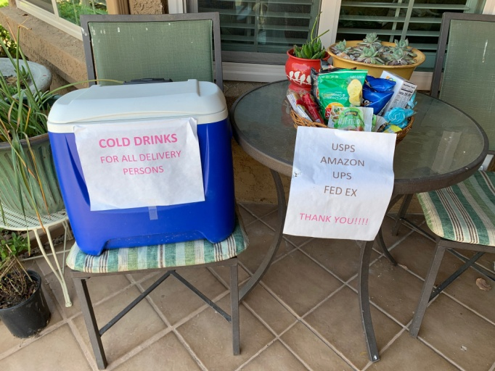

**prayer requests**








**Hot *New* Service Project!  Help assemble 300,000 N95 Respirators for the Office of Emergency Services**.

North Coast Church is partnering with the Rock Church to assemble 300,000 N95 masks.  Many hands are needed for this project!  Health screening processes are in place and social distancing guidelines followed for all volunteers to ensure everyone’s safety.  Must be 18-64yrs. Pt Loma Location Daily M-F 9am-3pm.  San Marcos Location: Daily M-F 9am-3pm.

**To sign up or get more info go to:** [www.northcoastcommunityservice.org](http://www.northcoastcommunityservice.org)​ and search "respirators".