Pastor Chris Brown
February 22-23, 2020
Message #4/Acts 2:14-47
northcoastchurch.com/sermons

The Difference The Holy Spirit Makes

What happened?
Acts 2:14-47

The difference of the Holy Spirit:

With Jesus, Peter had:

Great FAITH—wrong FOCUS
Matthew 14:22-33

Great DEVOTION—wrong DIRECTION
Matthew 16:13-28

Great DESIRE—wrong ACTIONS
Matthew 26:31-75

Great SALVATION—wrong PURPOSE
John 21:1-5

With the Holy Spirit, Peter now has:

Great POWER—to go with his PURPOSE
Acts 2:14-16

Great FRUIT—to go with his FAITH
Acts 2:37-41

Great GIVER—to go with his GIFTS
Acts 2:43

Applying it to today:
Romans 5:6-11, 8, 12:1-2, Ephesians 4:7-28, Galatians 2:20, 5:13-26

The Christian life is more than just knowing THE FACTS,
it is learning to walk IN THE SPIRIT.

The sweet spot for every Christian is to be used by THE CREATOR
for what we were CREATED TO DO.

Life Group Study Questions
For the week of February 23, 2020

Quick review

Looking back at your notes from this week’s teaching, was there anything you heard for the first time, caught your attention, challenged or confused you?

My story

1. Take 60 seconds and write down as many things as you can that you do well. Come up with at least 10!

2. We learned the sweet spot for every follower of Jesus is to be used by the Creator for what we were created to do. Have you ever sensed you were in your sweet spot? If so, what was that like?

3. Do you feel like your purpose changed as you started following Jesus? If yes, how so?

YOU ARE GIFTED

1. This week we took a look at Peter’s story and how the Spirit grew him, transformed his perspective and used him to impact others as the early church began to grow. Similarly, looking back at our own stories can also give us insight into how God’s Spirit has been at work getting our attention, encouraging us, convicting us and affirming our gifts and abilities. Answer the questions below in the context of your life’s timeline and be ready to share your responses with your group.

----------------------------------------------------------------------------------------------
Your Birthday Today

- When and how did God begin to get your attention about what it means to follow Him?

Can you think of any time when God’s Spirit got your attention and/or grew your awareness of Godly character (Galatians 5:22-23)? If so, explain. (Experiences with friends, situation in life, personal crisis/success, work situation, church event, etc.)
Galatians 5:22-23 New International Version (NIV)
²² But the fruit of the Spirit is love, joy, peace, forbearance, kindness, goodness, faithfulness, ²³ gentleness and self-control. Against such things there is no law.

- What talents and/or abilities do you love to use? Have you ever thought they were given to you to impact the Kingdom?

- Can you think of any significant events or things that impacted your faith journey?

Looking back at what you just wrote, is there anything specific to how the Spirit has helped you to grow or may want to use you to help make an impact?

2. What you wrote above about your story is an important part of understanding your sweet spot or spiritual gift(s). Your abilities, passions and spiritual gifts are often tied together. A key to finding your sweet spot is to just start serving. Over time you’ll usually find yourself moving toward areas of passion and interest. There are many spiritual gifts inventories that can help you further investigate what yours may be. It’s important to know when taking one of these, there is no pass or fail, or final determination of what you are or are not gifted to do. Here’s a link to an online inventory that can help you begin to investigate what one of your sweet spots may be and how the Spirit wants to work in your life.

Gift Inventory - https://giftstest.com/test/signup
Definitions of Spiritual Gifts - https://giftstest.com/allgifts

3. Regardless of the spiritual gifts and abilities we’ve been given, we all have the ability to use our speech in order to influence other people. Whether you communicate more like Peter or tend to be on the softer side, your words are important and have impact. How do the following verses help us understand the gift and power of our words so we can communicate in ways that have a positive impact?

James 3:13-17 New International Version (NIV)
Two Kinds of Wisdom
¹³ Who is wise and understanding among you? Let them show it by their good life, by deeds done in the humility that comes from wisdom. ¹⁴ But if you harbor bitter envy and selfish ambition in your hearts, do not boast about it or deny the truth. 15 Such “wisdom” does not come down from heaven but is earthly, unspiritual, demonic. ¹⁶ For where you have envy and selfish ambition, there you find disorder and every evil practice.
¹⁷ But the wisdom that comes from heaven is first of all pure; then peace-loving, considerate, submissive, full of mercy and good fruit, impartial and sincere.

Ephesians 4:1-3 New International Version (NIV)
Unity and Maturity in the Body of Christ
⁴ As a prisoner for the Lord, then, I urge you to live a life worthy of the calling you have received. ² Be completely humble and gentle; be patient, bearing with one another in love. ³ Make every effort to keep the unity of the Spirit through the bond of peace.

2 Timothy 2:23-25 New International Version (NIV)
²³ Don’t have anything to do with foolish and stupid arguments, because you know they produce quarrels. ²⁴ And the Lord’s servant must not be quarrelsome but must be kind to everyone, able to teach, not resentful. ²⁵ Opponents must be gently instructed, in the hope that God will grant them repentance leading them to a knowledge of the truth,

What advice would you give a Christian who continually tries to win spiritual arguments, but ends up offending or ostracizing others?

Which of these verses is most important for you to hear when it comes to your words?

taking it home

Looking back at this week’s teaching and study, what is most important for you to remember and why?

Prayer Requests

_______________________________________________________________

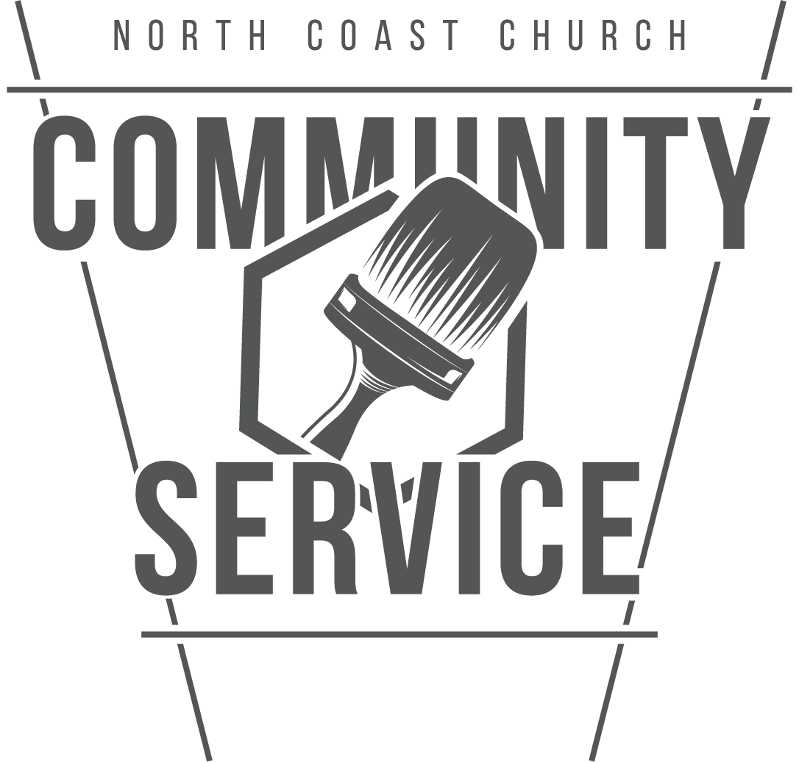 | Community Service Impact  Community Service is a ministry of North Coast Church dedicated to being the hands and feet of Jesus and showing God’s love in tangible ways through service to the community. There are many options for you to serve. For ideas, check out NorthCoastCommunityService.org

