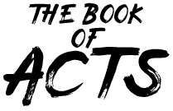 | Pastor Chris Brown  February 15-16, 2020  Message #3 / Acts 2:1-13
 | northcoastchurch.com/sermons

The Giving of the Holy Spirit
(The Gift of Tongues)

What happened?
Acts 2:1-13

How did it happen?
Acts 1:7-8, 2:1-4

- The disciples were WAITING on the Spirit, not
SEARCHING AFTER Him.

They were waiting in the PROMISES of Jesus.

They were waiting in their FAITH IN Jesus.

They were waiting in their WEAKNESS, not STRENGTH.

Can it happen today?
Ephesians 1:13-14, John 3:5, 2 Corinthians 1:22, Romans 8:22-27, 1 Corinthians Chapters 12-14,
2 Timothy 3:16-17

- Every Christian has been given the HOLY SPIRIT and GIFTS.

- The Spirit will never work against the BIBLE He WROTE.

- We walk in the Spirit by REMAINING, REMAINING, REMAINING…

We receive the Spirit the moment we are SAVED.

The filling of the Spirit is an ONGOING PROCESS.

Life Group Study Questions
For the week of February 16, 2020

Quick review

Looking back at your notes from this week’s teaching, was there anything you heard for the first time, caught your attention, challenged or confused you?

My story

1. There can be a lot of confusion about spiritual gifts in churches today, especially with the gifts like tongues and healing. Has your understanding of spiritual gifts changed over time? If so, explain how.

What has been the biggest influence on your understanding of spiritual gifts?

2. When you hear that you have at least one spiritual gift and God wants you to use it to serve Him and others, what response does that elicit? (Check all that apply)

□ Excited to figure it out  □ Still confused  □ Frustrated  □ Humbled that God wants to use me | □ Regularly using my gift(s)  □ Disappointed in what my gift is  □ Other_______________

On a scale of 1-10 (10 being high), how motivated are you right now to use your gift(s) and abilities to serve God and others?

digging deeper

1. God has given all His followers unique gifts and abilities that He wants us to use in order to serve Him and others. What are one or two gifts or abilities you think you have?

Read the following lists of spiritual gifts. Jot down the guidelines and insights you see in regard to using your gifts and abilities to benefit the kingdom.

Romans 12:4-8 New International Version (NIV)
⁴ For just as each of us has one body with many members, and these members do not all have the same function, ⁵ so in Christ we, though many, form one body, and each member belongs to all the others. ⁶ We have different gifts, according to the grace given to each of us. If your gift is prophesying, then prophesy in accordance with your faith; ⁷ if it is serving, then serve; if it is teaching, then teach; ⁸ if it is to encourage, then give encouragement; if it is giving, then give generously; if it is to lead, do it diligently; if it is to show mercy, do it cheerfully.

1 Peter 4:7-11 New International Version (NIV)
⁷ The end of all things is near. Therefore be alert and of sober mind so that you may pray. ⁸ Above all, love each other deeply, because love covers over a multitude of sins. ⁹ Offer hospitality to one another without grumbling. ¹⁰ Each of you should use whatever gift you have received to serve others, as faithful stewards of God’s grace in its various forms. ¹¹ If anyone speaks, they should do so as one who speaks the very words of God. If anyone serves, they should do so with the strength God provides, so that in all things God may be praised through Jesus Christ. To him be the glory and the power for ever and ever. Amen.

Exodus 31:1-6 New International Version (NIV)
Bezalel and Oholiab
31 Then the Lord said to Moses, ² “See, I have chosen Bezalel son of Uri, the son of Hur, of the tribe of Judah, ³ and I have filled him with the Spirit of God, with wisdom, with understanding, with knowledge and with all kinds of skills— ⁴ to make artistic designs for work in gold, silver and bronze, ⁵ to cut and set stones, to work in wood, and to engage in all kinds of crafts. ⁶ Moreover, I have appointed Oholiab son of Ahisamak, of the tribe of Dan, to help him. Also I have given ability to all the skilled workers to make everything I have commanded you:

The use of our God-given gifts and abilities are not limited to the church. Can you think of any ways you could use them in places other than our church (like your workplace, school or home) to serve others?

What stands out to you the most from these three passages?

2. The gifts and abilities God has given us come with the expectation that we will use them to play a role in God’s kingdom. Paul uses the analogy of the human body in 1 Corinthians 12:4-26 to describe what it looks like when we all play our part. As you read this passage, what are some of the things that catch your attention in regard to the various roles we play?

1 Corinthians 12:4-26 New International Version (NIV)
⁴ There are different kinds of gifts, but the same Spirit distributes them. ⁵ There are different kinds of service, but the same Lord. ⁶ There are different kinds of working, but in all of them and in everyone it is the same God at work.
⁷ Now to each one the manifestation of the Spirit is given for the common good. ⁸ To one there is given through the Spirit a message of wisdom, to another a message of knowledge by means of the same Spirit, ⁹ to another faith by the same Spirit, to another gifts of healing by that one Spirit, ¹⁰ to another miraculous powers, to another prophecy, to another distinguishing between spirits, to another speaking in different kinds of tongues,^{[a]} and to still another the interpretation of tongues.^{[b]} ¹¹ All these are the work of one and the same Spirit, and he distributes them to each one, just as he determines.
Unity and Diversity in the Body
¹² Just as a body, though one, has many parts, but all its many parts form one body, so it is with Christ. ¹³ For we were all baptized by^{[c]} one Spirit so as to form one body—whether Jews or Gentiles, slave or free—and we were all given the one Spirit to drink. ¹⁴ Even so the body is not made up of one part but of many.
¹⁵ Now if the foot should say, “Because I am not a hand, I do not belong to the body,” it would not for that reason stop being part of the body. ¹⁶ And if the ear should say, “Because I am not an eye, I do not belong to the body,” it would not for that reason stop being part of the body. ¹⁷ If the whole body were an eye, where would the sense of hearing be? If the whole body were an ear, where would the sense of smell be? ¹⁸ But in fact God has placed the parts in the body, every one of them, just as he wanted them to be. ¹⁹ If they were all one part, where would the body be? ²⁰ As it is, there are many parts, but one body.
²¹ The eye cannot say to the hand, “I don’t need you!” And the head cannot say to the feet, “I don’t need you!” ²² On the contrary, those parts of the body that seem to be weaker are indispensable, ²³ and the parts that we think are less honorable we treat with special honor. And the parts that are unpresentable are treated with special modesty, ²⁴ while our presentable parts need no special treatment. But God has put the body together, giving greater honor to the parts that lacked it, ²⁵ so that there should be no division in the body, but that its parts should have equal concern for each other. ²⁶ If one part suffers, every part suffers with it; if one part is honored, every part rejoices with it.

When it comes to spiritual gifts, it’s easy to fall into gift projection or gift envy. Gift projection is where we project a gift or ability we have on others and expect them to be able to do what we do. Gift envy is where we desire a certain gift or ability so much that we attempt to get it, or we idolize those who have it. Have you ever struggled with either of these?

Have you ever felt like some gifts are more important than others? If so, which ones?

All Christians have been given gifts and abilities to serve on God’s team, yet not all Christians are playing their part. What hindrances can you think of that keep people from using their gifts and abilities to play their part?

taking it home

1. In addition to the one or two gifts/abilities you jotted down in Digging Deeper #1, are there any other gifts and strengths you believe God has given you? (Possible areas you might want to consider: your passions and interests, abilities, personality and experiences.)

How are you currently investing your gifts/abilities in building God’s kingdom?

Is there anything specific you sense God calling you to start doing now as a result of this weekend’s teaching and study?

2. One of the key ways to find out what your gifts and abilities are is to jump in and start serving. Below is just a sampling of the many ministries within North Coast Church where you could use your abilities. Are there any new service opportunities you need to consider (or reconsider) as a result of this week’s study?

□ Children’s Ministries (nursery - 5th grade)
□ Connections: Coffee, Greeters, Usher/Hosts, Welcome Center
□ Creative team
□ Midweek Admin team
□ Parking Ministry
□ Prayer team
□ Tablecloth/Laundry ministry
□ Tech team
□ Safety team
□ Scrip booth

Ready to get involved?

- Go to northcoastchurch.com/volunteer to begin the process
- Stop by your Campus Welcome/Info booth this weekend
- Call 760-724-6700

_______________________________________________________________

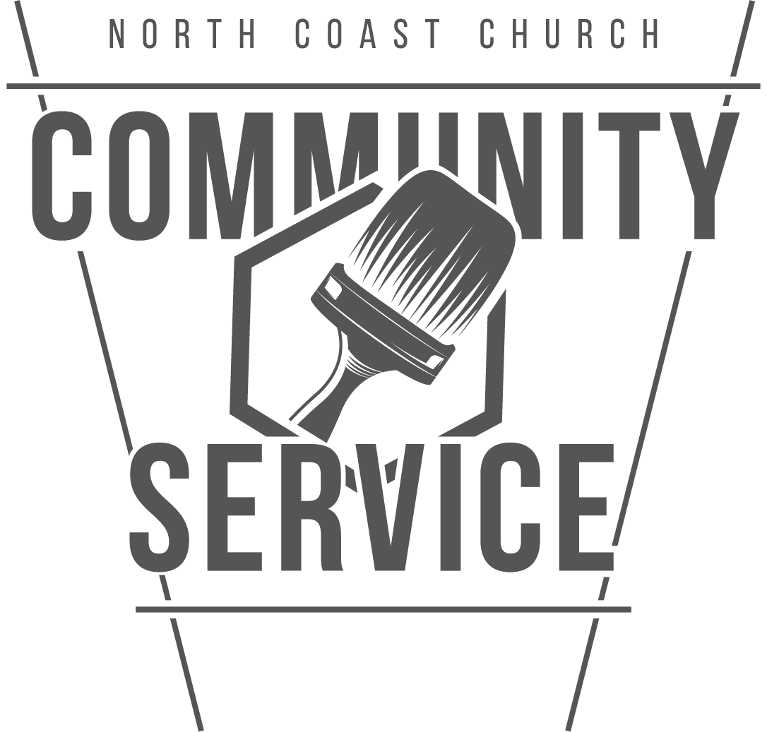 | Community Service Impact  Community Service is a ministry of North Coast Church dedicated to being the hands and feet of Jesus and showing God’s love in tangible ways through service to the community. There are many options for you to serve. For ideas, check out NorthCoastCommunityService.org

